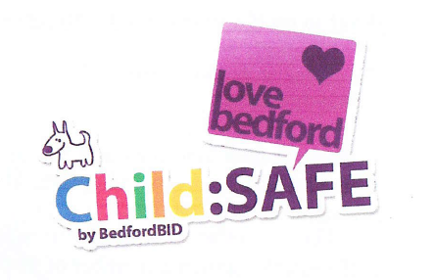


BedfordBID Child:SAFE

BedfordBID offers parents and guardians with small children free wristbands at town centre events.

The wristbands have a space for parents/guardians to write their emergency contact numbers on, so that, in the unfortunate event that they are separated from their child during their visit, there is a quick and easy way of contacting them.

What to do if you find a missing child:
Should you have a child in your shop who has become separated from their family, we have asked parents to advise children seek out a till cashier and not to leave your store.

If you are approached by a child who believes that they are lost or find a child wandering in your store who looks like they have been separated from their parents/guardians, please could you ask your staff to follow this procedure:

1. Check if the child is wearing a Child:SAFE wristband. Their parent’s/guardian’s emergency contact number should be written on the band. You can contact them directly on this number.

2. If not, ask the child directly who they are with and where their parents are if they are very young.

3. If they do not know, ask another colleague to assist you, as it is advisable to always have two adults present with minors. Please do not take the child to your staff rooms and if the child needs to use the toilet make sure that you have a female colleague who can assist and be present.

4. If you are a member of BedfordBID Retail RadioLink scheme, an immediate call is to be placed over the radio to announce that you have found a missing child. You will be asked for a full description of the child in your care and for any information regarding the people who they were with. A BedfordBID Town Centre Champion will come to assist you. If you do not have a radio, you can call BedfordBID on 01234 404500 where your call will be treated as a priority and someone will be contacted for you.

